Angular 6/7/8

create new project : ng new <projectname>
run project : ng serve

folder structure:

e2e – end to end testing
node-modules – node modules in angular app
src – 1) component
commnd to create component – n g c <name>
<name>.component .css – stlyle of component
<name>.component .html – template of component
<name>.component.ts - logic of typescript
<name>.module.ts – which feature/module use in angular app
<name>.component.spec.ts – for testing purpose
2) index.html – single page which render on browser
3) style.css – for global styling
4) angular.json – which package use in current angular app
5) package.json - which package in angular app
6) package-lock.json - angular app package current version lock
7) asset – which image use in project

Data Binding:

1) One way data binding :
TS file -------> html/view
i) string interpolation : {{data}} – only support string
ii) property binding : [value] = ‘data’ - support string and other also like boolean
[disabled] = true [hideen] = true
iii) class binding : for single [class.<calssame>] = true or multiple [ngClass] = ‘myClass’
ts file myClass ={
class1 : true,
class2 : true
}
iv) style binding : for single [style.margin]=’15px’ or multiple [ngStyle] = ‘myClass’
ts fiile myClass = {
‘background-colour’ : ‘red’,
‘width’ : ‘100px’
}

TS file <------- html/view
v) event binding :
(click) = “onAdd()”
(click) = “onAdd($event)”
$event : give information about particular event

➤ Events for your Reference

(focus)="myMethod()" // An element has received focus
(blur)="myMethod()" // An element has lost focus
(submit)="myMethod()" // A submit button has been pressed
(scroll)="myMethod()"
(cut)="myMethod()"
(copy)="myMethod()"
(paste)="myMethod()"
(keydown)="myMethod()"
(keypress)="myMethod()"
(keyup)="myMethod()"
(mouseenter)="myMethod()"
(mousedown)="myMethod()"
(mouseup)="myMethod()"
(click)="myMethod()"
(dblclick)="myMethod()"
(drag)="myMethod()"
(dragover)="myMethod()"
(drop)="myMethod()"

Local reference/Template reference variable:
html
#app template reference variable
<input #app type="text" value="akshay" name="anup" >
<button (click)="myInput(app)">add</button>

ts
myInput(my){
console.log(my.value)
}

console – akshay

2) Two way binding:

import formmodule for two way data binding
TS<------> html

html
<input type="text" [(ngModel)]="uName">
<p>{{uName}}</p>

ts
uName : string = “aksghay”

app.module.ts

import { FormsModule } from '@angular/forms';

@NgModule({
declarations: [
AppComponent,
MyContainerComponent, ----------declarations add the created component
TopnavComponent,
DataBindingComponent
],
imports: [
BrowserModule,
AppRoutingModule, ---------- add import inbuilt module
FormsModule
],
providers: [], ----------------- add services here
bootstrap: [AppComponent]
})

ngx-Bootstrap:

link : - https://ng-bootstrap.github.io/#/getting-started
ng add @ng-bootstrap/ng-bootstrap angular >=9

types of directives:
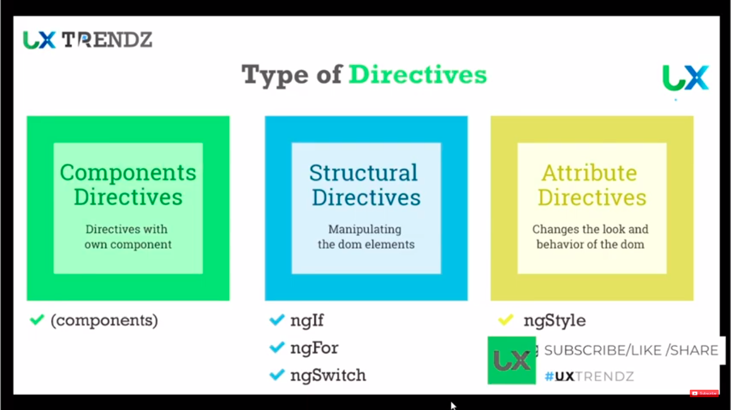

ngIf

<div *ngIf="isValid; then thenTemplateName else elseTemplateName">
<ng-template #thenTemplateName>
If isValid is true
</ng-template>
<ng-template #elseTemplateName>
If isValid is false
</ng-template>
</div>

ngSwitch

<container-element [ngSwitch]="switch_expression">
<element *ngSwitchCase="’condition1’">Case 1 content</element>
<element *ngSwitchCase="’condition2’">Case 2 content </element> ....
<element *ngSwitchDefault>Default content</element>
</container-element>

ngFor:
ts
people : any []=[
{ name : akshay, number:12},
{ name : akshay,s number:32},
{ name : akshasy, number:22}
]

push pop splice use in add in array using event

html
<th>
<td>Sr. No.</td>
<td>Name</td>
<td>Number</td>
</th>
<tr *ngFor="let person of people; index as i”>
index instead even odd last first make true to all
<td>{{ i }}</td>
<td>{{ person.name }}</td>
<td>{{ person.number}}</td>
</tr>

------------------------------------------------------------------------------------------------------------------------

Routes:

html

<nav>
<a [routerLink]="/home" routerLink=”active” routerLinkActiveOptions=”{{exact.true}}”>Home</a>
<a [routerLink]="/contacts" routerLink=”active”>Contacts</a>
<a [routerLink]="/products" routerLink=”active” >Products</a>
</nav>

<router-outlet></router-outlet>

app-routing.module.ts
import { NgModule } from '@angular/core';
import { Routes, RouterModule } from '@angular/router';
import all componet also here

const routes: Routes = [
{ path: '', redirectTo:’login’, pathMatch:’full’}, --- first page open when open website
{ path: 'home', component: HomeComponent},
localhost:4200/home
{ path: 'contacts', component: ContactComponent},
localhost:4200/contacts
{ path: 'login', component: ContactComponent},
localhost:4200/login
nested route
{ path: 'products', children:[
{path:’’ , component: ProductComponent}, localhost:4200/products
`{path:’laptop’ , component: LaptopComponent}, localhost:4200/products/laptop
{path:’computer’ , component: ComputerComponent} localhost:4200/products/computer
},
{ path: '**', component: PageNotComponent},
localhost:4200/aboutUsfgssdd ---enter wrong url
this called wildcard route always put at last in route array
];

@NgModule({
imports: [RouterModule.forRoot(routes)],
exports: [RouterModule]
})
export class AppRoutingModule { }

Navigate the route

import { Routes, RouterModule } from '@angular/router';

constructer(private router : Router ) { }

this.router.navigate([‘path where to navigate like products’])
-----------------------------------------------------------------------------------------------------------------------
ng-content - having same html card but having some filed different the use
ng-container tag use when we want no unnecessary Tag add into dom

component communiction :
use to create custom
child <-------- parent
child ts
@Input()

child ------> parent
child ts
@Output() varible name = new EventEmitter<type>()

addProduct(){
this.variable name.emit()
}
------------------------------------------------------------------
Services
ng g s <servicename>
store the data use any where in component.

Where want to use service
constructer (private _<any name>: ServiceName){
}
-----------------------------------------------------------------
HttpClient module
to use fetch data from server
import this into service

observable and get in service
subscribe use in component where is to use

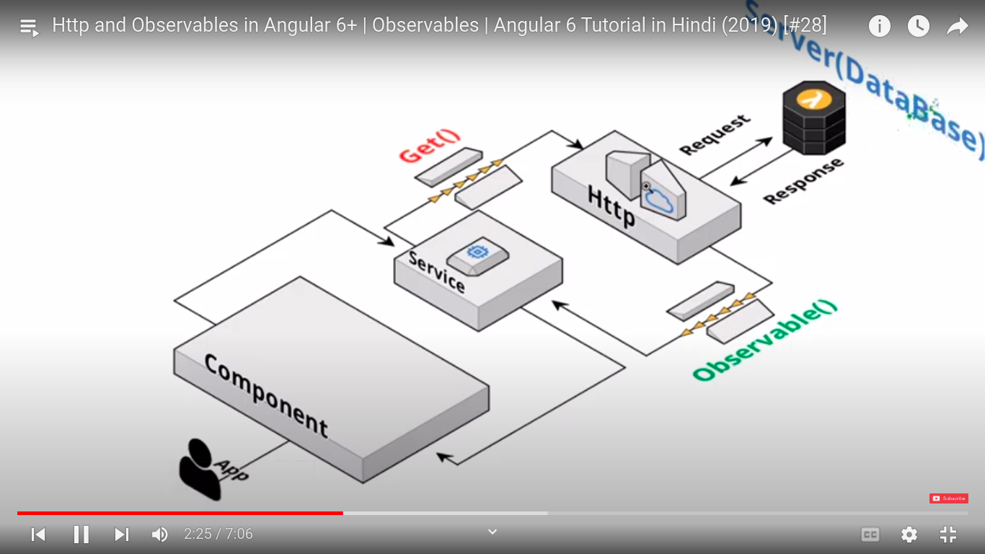
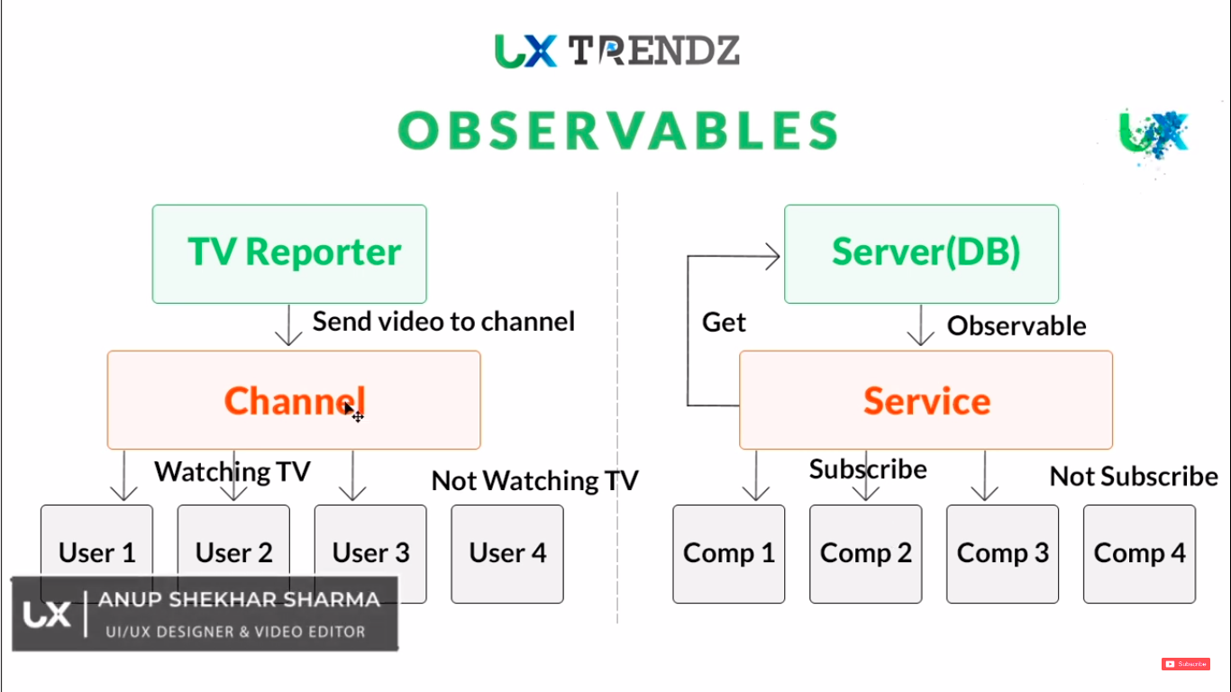

Subject and Behaviour Subject:
send info/data one to any component

COMPONENT LIFECycle hook:

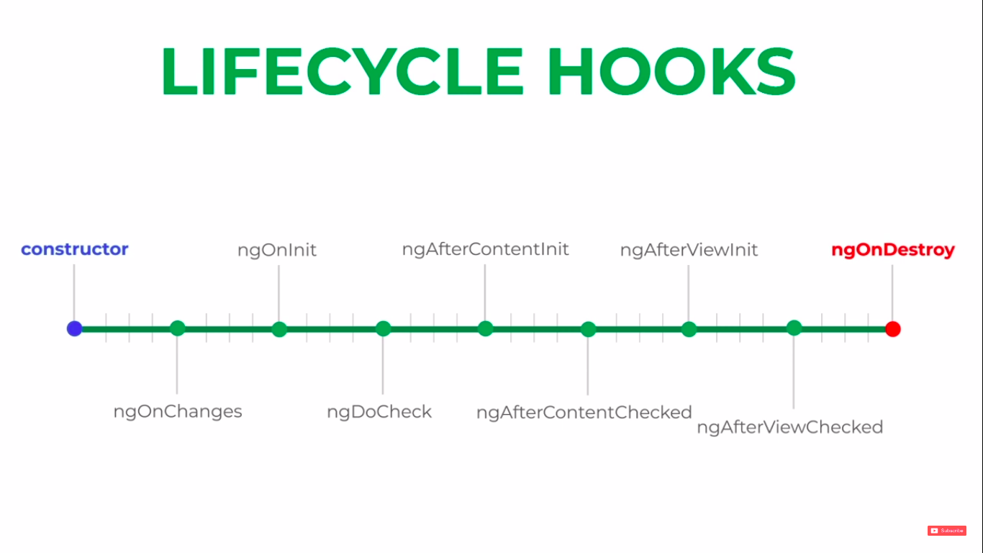
------------------------------------------------------------------
&nbsp --- its give space between two component

Viewchild:

@ViewChild(pass value of chlid) child : component name
@ViewChild(template variable) <anyName>: ElementRef

Renderer 2 --- this like service
@ContentChild(pass value of content child inside ngcontent template variable) <anyName>: ElementRef

this.render.<any method>(this.@ViewChild/@ContentChild,’attribute’,’content’)

viewchild using directive:

ng generate directive <name of directive> custom directive attached any specifice behaviour in dom

use this custome directive html tag

Host listener :

@HostListener ---- customize event any component or custome directive

Host Binding

Note
for dom u set colourproperty u write in camel case like style = backgroundColour
for class u set any style property u write like style = background-colour

@HostBinding (‘style.<prperty>’) <property name>
@HostBinding (‘class<className>’) <className>
@HostBinding (‘attr<attributeName>’) <attributeName name>

@HostListener(‘event’) ,<name>(){
this.<property name>=’ any propery value like colour blue’
this.<className> = true
this.<attributeName name>=’ any value like title add title value’
}

Pipes:

{{value | any method}} ----single pipe
{{value | any method | any method }} ------ multiple

custom pipes

ng generate pipe custom
{{value | custom pipe}}

Pure pipes and impure pipes

pure -- doesn’t excute every changes
impure – excute every change -----don’t use project

Template And Rwactive Forms
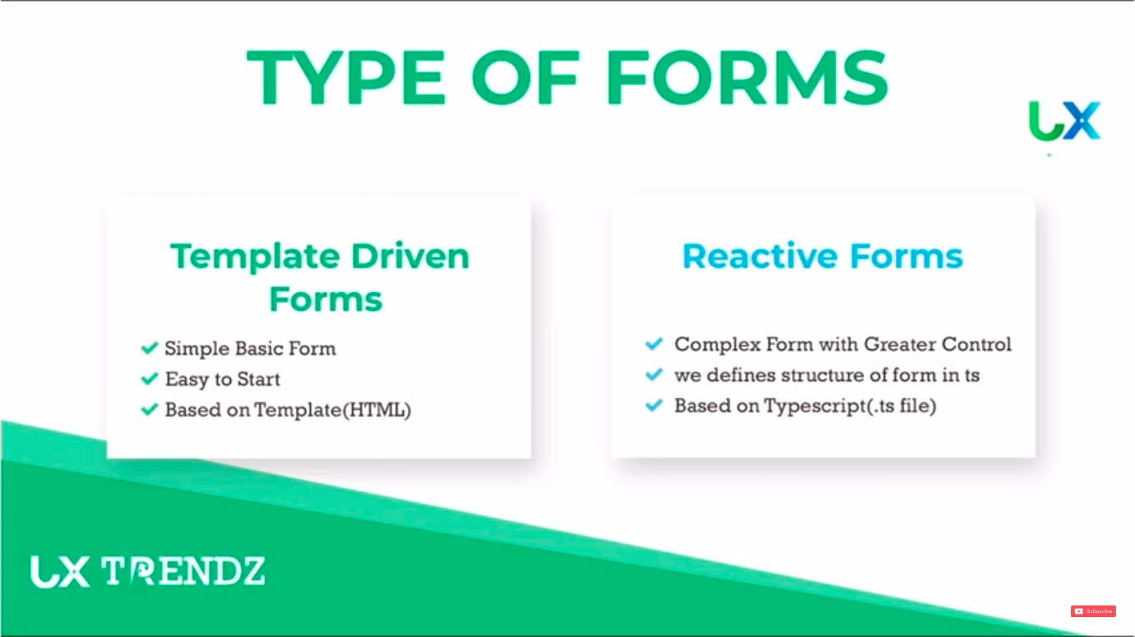

Modules

app.modules.ts ---- main modules

Featured Modules -----separate modules for all service , component, routes, directives

Modules Loading :

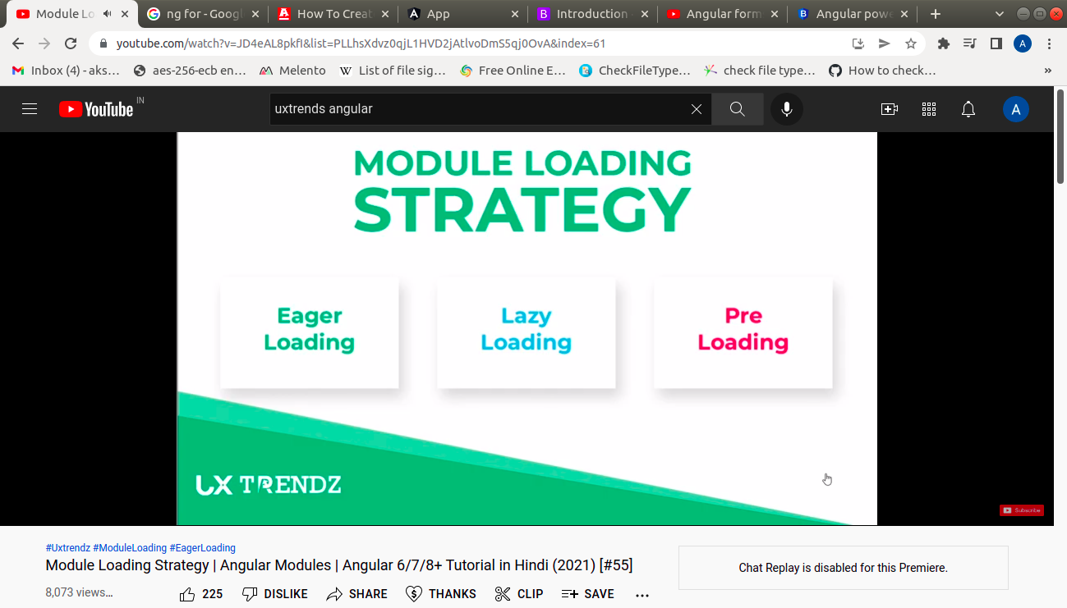
--------------------------------------------------------------------------------------------------------------ngx-translate– translate website in any language.

Http module to coonect server api:
saveproducts.service.ts

const url = url of end point of api
saveProducts(params){
return this.http.<method like put,post>(ths.url,params)
}

products.component.ts
import service

constructor(private _saveProductsservice: saveproducts){}

const product= all data store which send to database
addproducts(this.product){
thi._saveProductsservice.saveProducts(this.product).subscribe(
(response)=> {console.log(response},(error)=> {console.log(error})
}
method name :
Post – create
Put?patch – update
Get - read/ retrive
Delete - delete

